NovaStore — Mini E-Commerce & Realtime Dashboard

Technical Assessment & User Documentation Submission Package

Candidate Name | Azmi Jalaluddin Amron
Email Subject | User Documentation-Azmi Jalaluddin Amron
Target Recipient | amartawiragunamandiri@gmail.com
Tech Stack | Next.js 16 (App Router, Turbopack), Supabase (PostgreSQL & Realtime), Tailwind CSS, Vercel
Live Production URL | https://shop.sourcecodejournal.dev  Alternative Vercel Edge: https://mini-e-commerce-and-realtime-dashbo-six.vercel.app/
Admin Demo Credentials | Email: admin@novastore.com • Password: admin12345  (Or click "⚡ Instant Demo Admin Access" on the login page)

Product Requirement Document (PRD)

Executive Summary & Mission
NovaStore is an enterprise-grade digital commerce platform engineered for single-merchant operations. It eliminates shopping barriers through a frictionless multi-product guest checkout while equipping store administrators and warehouse operators with a real-time command center powered by Supabase
PostgreSQL WebSockets.

Core Specifications & Functional Modules

    - Frictionless Guest Checkout (Multi-Product): Customers can browse items, adjust quantities, add multiple different products to the cart, and complete orders with zero registration or login
requirements.
    - Interactive Map Geolocation (OpenStreetMap & GPS): Integrated map coordinate visualizer with HTML5 GPS auto-location and interactive coordinate pinning.

    - Multi-Courier Logistics Engine: Real-time distance-based tariff estimation using the Haversine formula across JNE Express, J&T Express, Shopee Xpress, SiCepat, and Instant Courier.
    - 2.5% Administrative Service Fee: Automatically calculated as Math.round(cartTotal * 0.025)
and itemized transparently across checkout, confirmation receipts, and official corporate invoices.
    - Zero-Fee Direct Payment Verification: Direct 0% MDR Instant QRIS and Manual Bank Transfer (BCA, Mandiri) with payment receipt screenshot upload and 1-click admin approval/rejection.
    - Real-time Operations Dashboard: Real-time WebSocket subscriptions on PostgreSQL changes, visual KPI analytics graphs (Recharts), inventory CRUD, and 1-click CSV/Excel export.
    - Official Corporate Tax Invoices: Dedicated /invoice/[id] route formatted with DPP (Nilai Kena Pajak), PPN 11%, courier delivery line item, administrative fees, and verified scannable QR verification code.

Mathematical & Fee Formulations

- Product Subtotal = Sum(Unit Price × Quantity)
- Shipping Tariff = Base Cost + (Distance in KM × Tariff per KM)
- Admin Fee (Biaya Layanan 2.5%) = Round(Product Subtotal × 0.025)
- Grand Total = Product Subtotal + Shipping Tariff + Admin Fee
- Tax Base (DPP) = Round(Product Subtotal / 1.11)
- PPN 11% = Product Subtotal - DPP

Entity Relationship Diagram (ERD) & Database Schema

The database is architected on Supabase PostgreSQL with performance indexes and Row Level Security (RLS):

NOVASTORE — POSTGRESQL ENTITY RELATIONSHIP DIAGRAM (ERD)
Single-Merchant Digital Commerce & Real-time Operations Schema

📦 PRODUCTS 🛒 ORDERS

🔑 id: UUID (PK)
name: VARCHAR(255)
description: TEXT price: NUMERIC(12,2)
stock: INTEGER image_url: TEXT
category: VARCHAR(100) seller_email: VARCHAR seller_name: VARCHAR created_at: TIMESTAMPTZ

RLS: Public Read (SELECT) RLS: Admin Manage (ALL)

📋 ORDER_ITEMS

🔑 id: UUID (PK)
🔗 order_id: UUID (FK)
1:N 1:N
🔗 product_id: UUID (FK)
quantity: INTEGER
unit_price: NUMERIC(12,2) subtotal: NUMERIC(12,2) created_at: TIMESTAMPTZ

Multi-Product Support 1:N
🔑 id: UUID (PK)
customer_name: VARCHAR customer_email: VARCHAR customer_phone: VARCHAR customer_address: TEXT total_amount: NUMERIC admin_fee (2.5%): NUMERIC shipping_courier: VARCHAR shipping_cost: NUMERIC destination_lat/lng: NUMERIC payment_proof_url: TEXT payment_verified: BOOLEAN status: VARCHAR(50) payment_method: VARCHAR created_at: TIMESTAMPTZ

RLS: Public INSERT (Guest)

- products Table: id (UUID, PK), name (VARCHAR), description (TEXT), price (NUMERIC), stock (INTEGER), image_url (TEXT), category (VARCHAR), created_at (TIMESTAMPTZ).
- orders Table: id (UUID, PK), customer_name, customer_email, customer_phone, customer_address, total_amount, admin_fee, shipping_courier, shipping_cost,
destination_lat, destination_lng, payment_proof_url, payment_verified, status,
payment_method, created_at.
- order_items Table: id (UUID, PK), order_id (FK -> orders), product_id (FK -> products), quantity, unit_price, subtotal, created_at.

System Architecture & Flowchart (Alur Pikir)

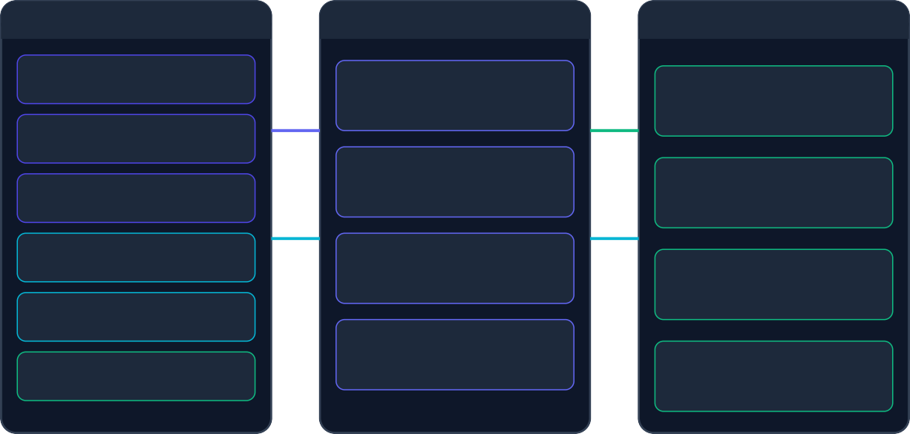
Step-by-Step System Flow (Alur Pikir)
NOVASTORE — SYSTEM ARCHITECTURE & DATA FLOW
Next.js 16 App Router & Supabase PostgreSQL Real-time WebSockets
🌐 CLIENT LAYER (UI/UX)
⚙ NEXT.JS APPLICATION LAYER
🗄 SUPABASE BACKEND LAYER
Guest Shopper Storefront
Catalog Search & Category Filters
App Router & Server Engine
Turbopack compilation
TypeScript Strict Architecture
PostgreSQL 15+ Database
products, orders, order_items Indexed query execution
Cart Drawer & Map Location
OpenStreetMap Pinning & Couriers

Guest Checkout Form
2.5% Fee & Proof Screenshot
Logistics & Tariff Matrix
Haversine distance calculation JNE, J&T, SPX, SiCepat, Instant
Supabase Realtime Engine
PostgreSQL CDC (Change Data) Instant WebSocket broadcasts
Admin Operations Dashboard
Live KPI Recharts & Orders Table
Financial Engine (2.5% Fee)
Automated platform fee formula Corporate PPN 11% Tax Invoicing
Payment Verification Lightbox
1-Click Approve / Reject Proof
Row Level Security (RLS)
Public Guest INSERT enabled Admin authenticated security
Official Corporate Tax Invoice
DPP + PPN 11% & QR Validation
CSV Financial Exporter
1-Click Excel/CSV report generator Full accounting transaction export
Supabase Auth Service
JWT Token session validation
Protected admin dashboard routes
- Customer Catalog & Multi-Product Cart: Customer browses catalog, specifies quantities, and adds items to the slide-over cart drawer.
- Map Location & Courier Selection: Customer opens checkout, pins GPS coordinates on the interactive map, and chooses their preferred courier.
- Fee Calculation & Payment Upload: System calculates the 2.5% administrative fee. Customer scans QRIS or transfers to bank accounts, attaching a payment receipt screenshot.
- Order Broadcast: Order is written to Supabase PostgreSQL, instantly triggering a real-time WebSocket push alert to the Admin Dashboard without page refresh.
- Admin Verification: Admin inspects the payment proof screenshot in full-resolution lightbox and 1-click approves the transaction.
- Fulfillment & Invoice: Order status transitions from Pending → Processing → Completed. Scannable corporate tax invoices are generated for customer verification.

Log Prompting AI (Catatan Prompt & Alur Pengerjaan)

Chronological breakdown of prompts, architectural iterations, and agent actions:

- Session 1 (Project Scoping & Rules): Formulated .agents/rules/AGENTS.md, analyzed Supabase free-tier limits, and designed the implementation plan.
- Session 2 (Database Schema & Scaffolding): Initialized Next.js App Router, created
supabase/schema.sql with RLS policies, and wrote preliminary documentation.

- Session 3 (Full-Stack Implementation): Built multi-product cart drawer, storefront product catalog, guest checkout, and real-time WebSocket dashboard with Recharts analytics.
- Session 4 (Database Sync & Persistence): Verified WebSocket broadcasts and updated RLS SELECT
policies for permanent order persistence.
- Session 5 (Modern UI/UX & Invoices): Eliminated window.confirm() in favor of custom
glassmorphism modal dialogs, built dedicated /invoice/[id] corporate tax invoice route with QR code, and added 1-click CSV export.
- Session 6 (Logistics & 2.5% Admin Fee Engine): Built MapLocationPicker with GPS and
OpenStreetMap, multi-courier matrix (JNE, J&T, SPX, SiCepat, Instant), 2.5% admin fee arithmetic, and payment proof receipt screenshot uploader.
- Session 7 (Cross-Browser Polish & Seeder): Added cross-browser styling (Chrome, Edge, Safari, Firefox), sleek dark scrollbars, backdrop blur fallbacks, and 1-click interactive database seeder.
- Session 8 (Single-Merchant Architecture & Final Submission): Streamlined architecture to pure
single-merchant operations, removed registration confusion, added QRIS screenshot proof verification, created database reset script, and compiled Word/PDF documentation.

UI Screenshots & Visual User Documentation (Non-Teknis)

High-resolution visual walkthrough captures of all key application flows:

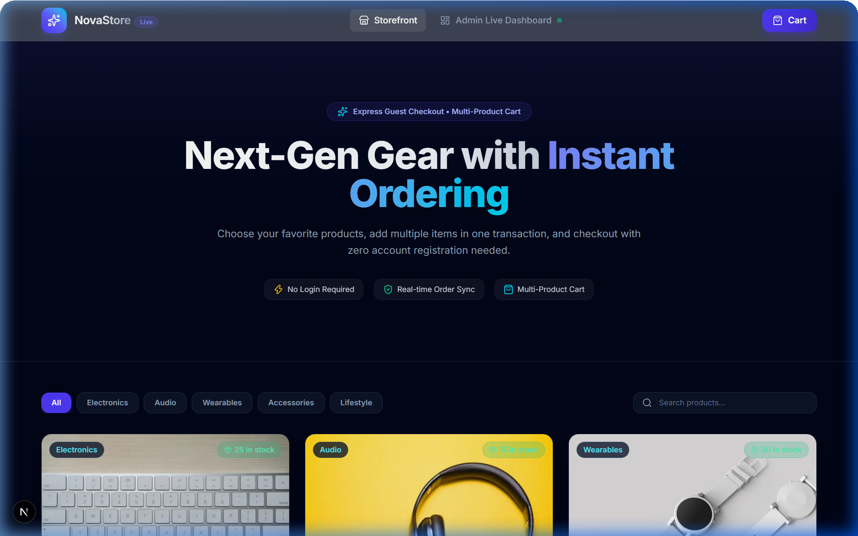

5.1 Storefront Homepage (Public Catalog & Search): Clean dark-mode storefront displaying product catalog, stock badges, live search bar, and category filters (Electronics, Audio, Wearables, Accessories, Lifestyle).

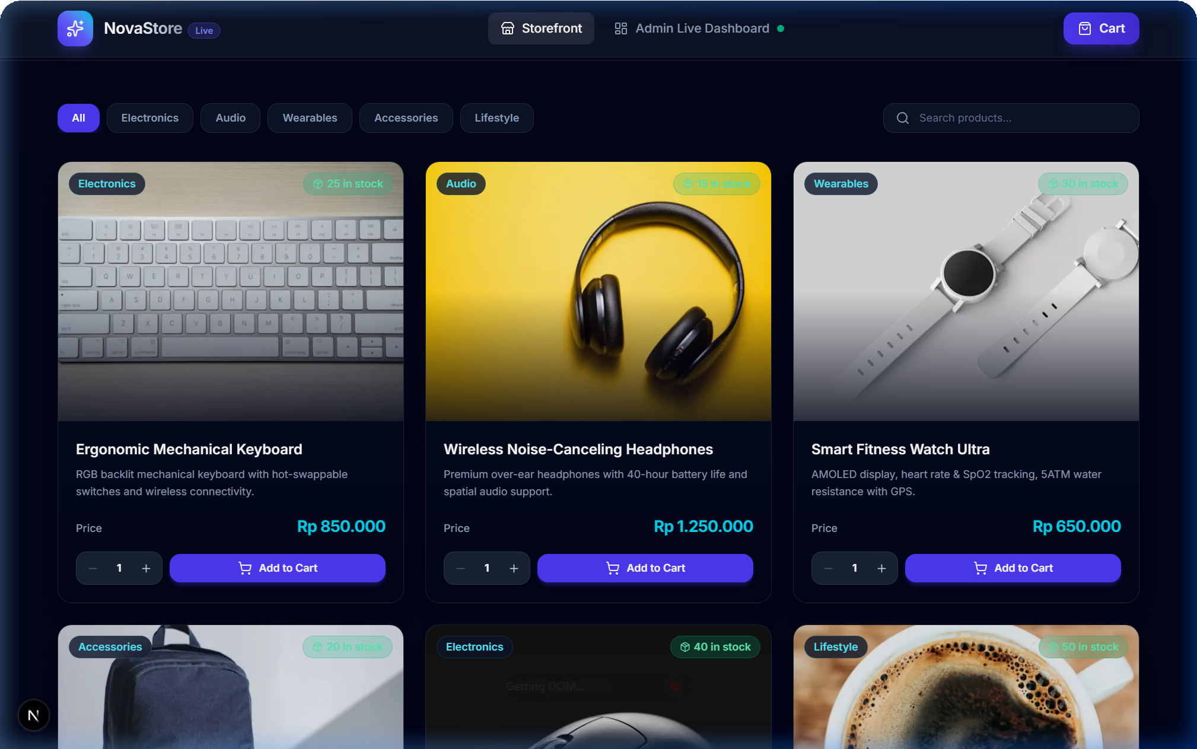
5.2 Product Catalog Grid & Quantity Adjusters: Interactive product cards with quantity selectors and "Add to Cart" triggers providing instant visual feedback.


5.3 Slide-Over Multi-Product Cart Drawer: Drawer allowing customers to manage multiple different products, view subtotal calculations, and proceed directly to guest checkout.

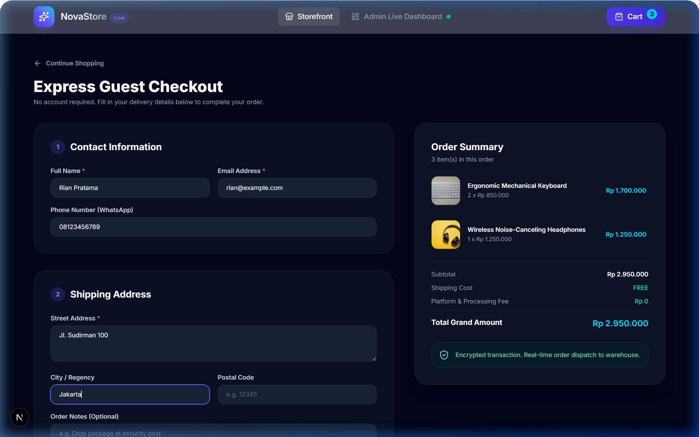

5.4 Express Guest Checkout Form & Map Geolocation: Frictionless checkout requiring zero login. Integrates OpenStreetMap GPS pinning, dynamic multi-courier selection, automatic 2.5% administrative fee calculation, and QRIS / Bank Transfer receipt screenshot uploader.


5.5 Order Confirmation & Confetti Celebration: Celebratory order confirmation featuring a unique UUID, itemized receipt, and direct links to view the corporate tax invoice.

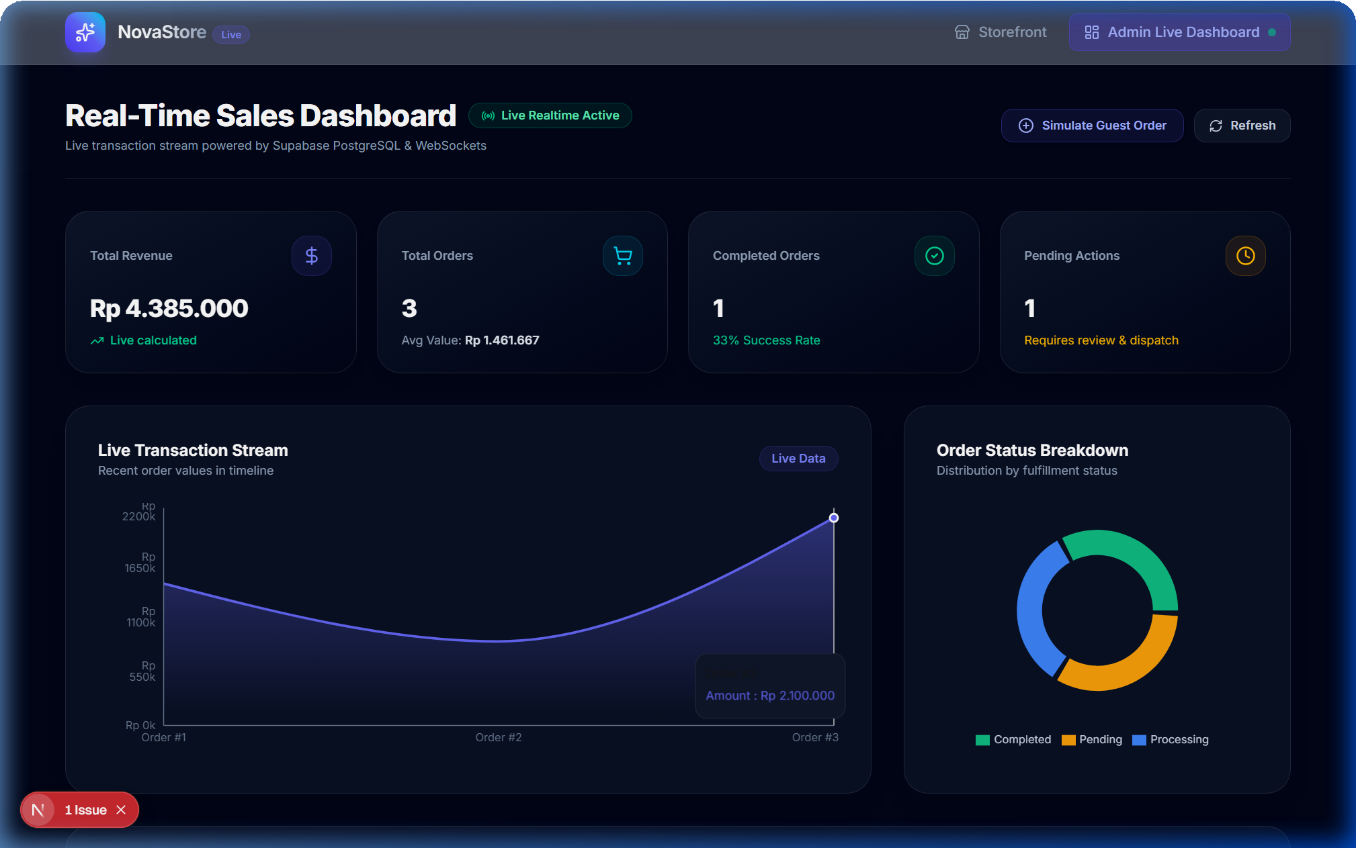

5.6 Real-Time Admin Operations Dashboard: Operations command center featuring live KPI summary cards (Total Revenue, Order Count, Completed vs. Pending rates, AOV), visual Recharts revenue streams, and status donut charts.

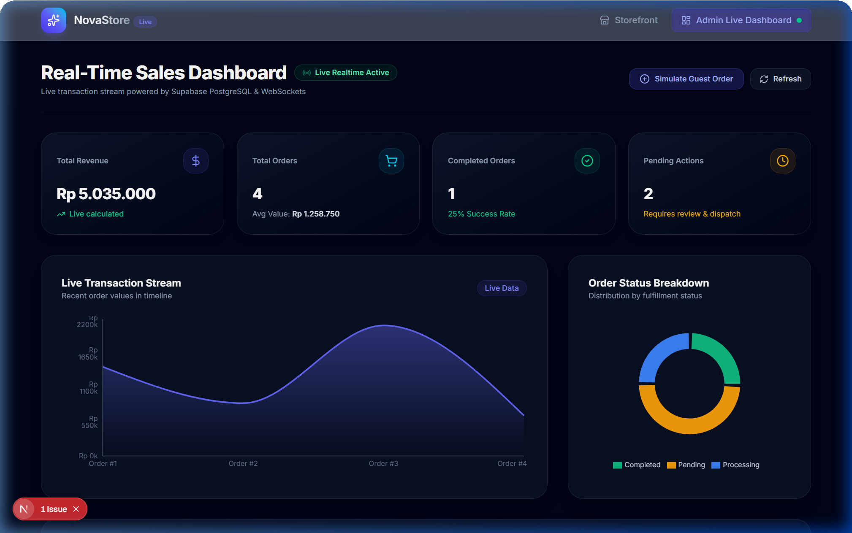
5.7 Live WebSocket Push Notification Alert: Instant push notification toast banner highlighting live incoming orders via Supabase PostgreSQL WebSockets without requiring a page refresh.

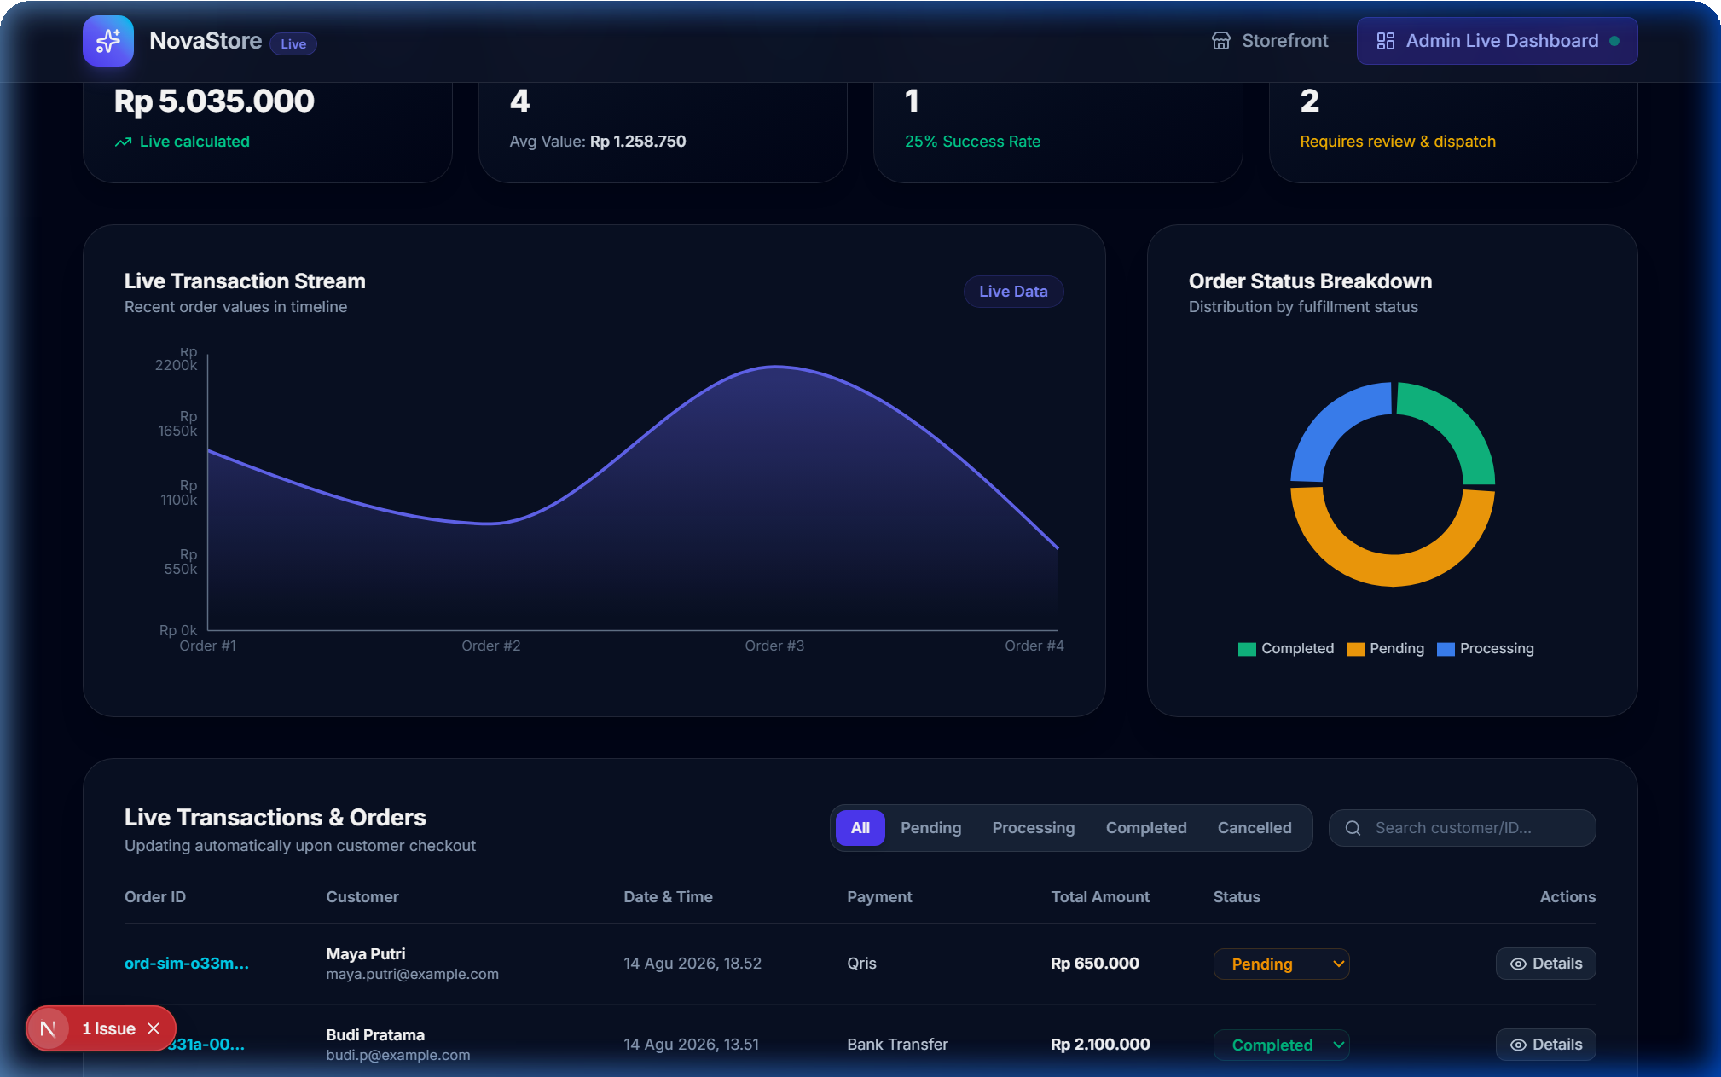
5.8 Live Orders Management Table & Courier Badges: Orders table with status dropdown switchers, search query filters, courier logistics badges, payment proof inspection triggers, and 1-click CSV export.

